Civil war in Somalia

UNSC Resolution: | 1474
Date of adoption: | 8-Apr-2003
Operative paragraph: | 1
Demand number: | 1474,0111

Sarah-Myriam Martin-Brûlé

Wording of demand
the obligation of all States and other actors to comply fully with resolution 733 (1992)

List of addressees of the demand
- Government of Somalia

Short-term compliance

Description of the addressee(s)’ conduct

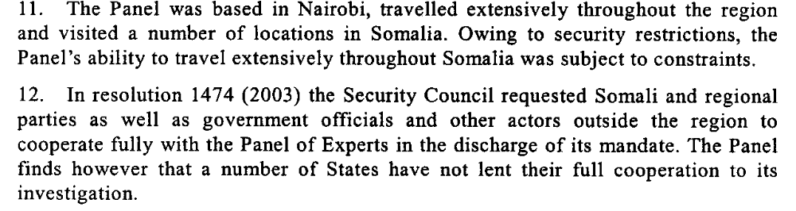

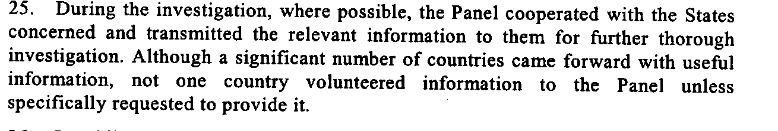

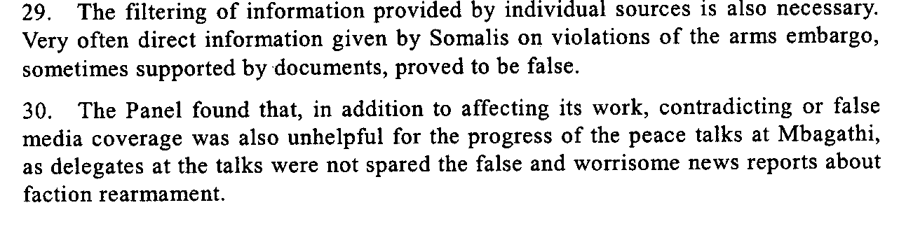

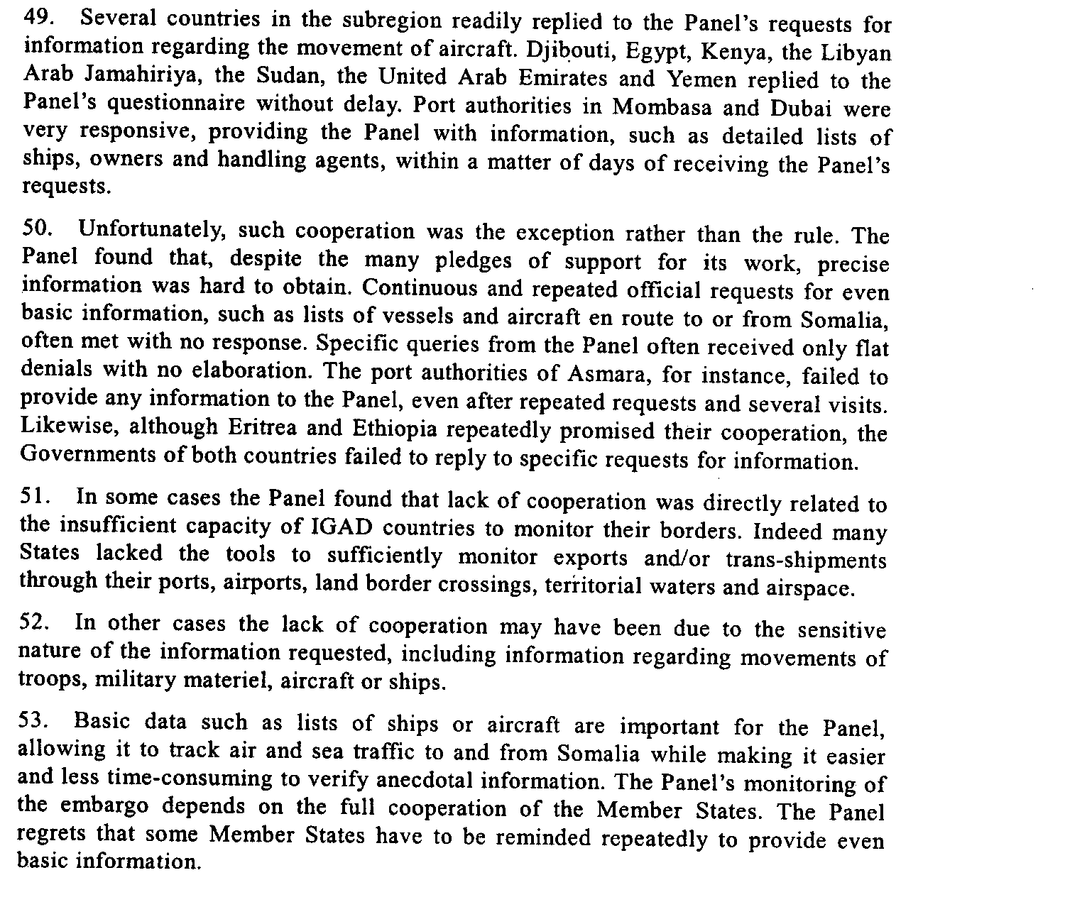
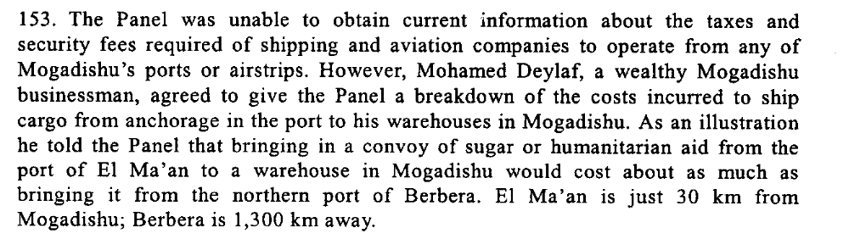

UN Security Council, Report of the Panel of Experts on Somalia Pursuant to Security Council Resolution 1474 (2003), 4 November 2003, S/2003/1035
http://www.unhcr.org/refworld/country,,UNSC,,SOM,456d621e2,46cbf2be0,0.html

The first phase of the Conference resulted in the signing of the Declaration on Cessation of Hostilities and the Structures and Principles of the Somalia National Reconciliation Process on 27 October 2002 (see S/2002/1359, annex). That was followed in December by two agreements by Somali leaders on restoration of security and normalcy in the city of Mogadishu. The parties committed themselves to the facilitation of humanitarian access and humanitarian space for the international aid community. However, in my reports on Somalia of February and June 2003 (S/2003/231 and S/2003/636), I noted with concern the numerous reports of violations of the ceasefire by its signatories. . While relative stability prevails and has improved in the northern regions, Somalia continues to suffer from violence and armed conflict throughout much of the southern and central areas. In the early part of 2003, fighting affected the Bay, Middle Juba, Mudug and Lower Shabelle regions, as well as Mogadishu. Tensions have also limited access to the Sool, Sanaag, Middle Shabelle and Gedo regions. The heaviest conflict has been around the once stable humanitarian base of Baidoa, where fighting among the factions of the Rahanwein Resistance Army (RRA) have forced international aid staff and a number of the Somali community to leave the town. In addition, clan conflicts around Bu’aale in the Middle Juba region have claimed scores of lives. Access of United Nations international staff to Mogadishu remains restricted owing to ongoing clan conflict and criminal activity. Mogadishu is home to an estimated 20 per cent of the Somali population, including 150,000 internally displaced persons, many of whom have been displaced for over a decade.
While the southern and central regions remain largely characterized by violence and armed conflict, security has improved in the Juba regions, in particular in the area of Kismayo, where local leaders have created a relatively secure operating environment. “Somaliland” continues to stabilize, and 38 international non-governmental organizations (NGOs) and 11 United Nations agencies continue to work in this region in an increasingly coordinated manner. The first peaceful multi-party presidential elections were held on 14 April 2003. 10. In “Puntland”, conflict in 2002 that affected the access of international staff to the area has been resolved through negotiation, and a peace agreement was signed in May 2003 between the incumbent president and the opposition. This and a memorandum of cooperation negotiated with the “Puntland” administration has allowed humanitarian aid work to continue and for the United Nations system and its partners to take steps to expand operations there in support of peace-building, as well as to revitalize coordination mechanisms.

Fifty-eighth session Item 41 (b) of the preliminary list* Strengthening of the coordination of humanitarian and disaster relief assistance of the United Nations, including special economic assistance: special economic assistance to individual countries or regions

32. Security in the southern parts of Somalia, including Mogadishu, remains precarious. Mounting criminality in Mogadishu includes frequent abductions, carjackings and civilian deaths. An Italian national was held hostage in Mogadishu from 17 to 28 June and then released. On 2 July, Dr. Hussein Muhammad Nur, a brother of RRA leader Colonel Hassan Mohamed Nur (“Shatigadud”), was murdered. On 6 July, hundreds of medical workers in Mogadishu held a one-day work stoppage in protest of the killing. Moreover, fighting between the militias of Omar Mahmud Mohamed (“Finish”) and Mr. Sudi (“Yallahow”) continued in the Medina district, causing several civilian deaths. Incidents of violence, including the rape of children and the dismemberment of a young woman in August, have shocked even the hardened citizens of the city. During August, some efforts were made to establish neighbourhood security patrols. In at least one case, neighbouring security organizations fought over their boundaries. It is too early, however, to judge the impact of the patrols.
33. Tensions between Mr. Sudi and Mohammed Dhere, two Hawiye/Abgaal leaders, led to fierce clashes around Jawhar in July, although calm had been restored by early September. Some 50 people were reported killed in July around South Mudug, when Habr Gedir and Dir militias clashed over control of water.
34. Inter-clan fighting around Baidoa also continued. The confrontation, which is in part a leadership dispute within RRA, has prevented access to the town for 14 months and has claimed numerous lives. The protagonists regularly use landmines. The ferocity of the conflict is illustrated by episodes such as the killing of a young woman by one side on 18 June, which was followed by a series of revenge killings in which at least four young women were reported killed.

Report of the Secretary-General on the Situation in Somalia, 13 October 2003, S/2003/987.

Assessment

Short-term compliance
No or marginal compliance (1) | X Medium low compliance (2) | Medium high compliance (3) | Full or almost full compliance (4)

Considerations underlying the assessment
The demand addressee complied with those aspects of the demand which were of relatively low significance to the achievement of the objectives of the demand.

Medium-term compliance

Description of the addressee(s)’ conduct

27. Intermittent fighting continues in Somalia, and the prevailing insecurity and
violence continue to prevent the United Nations from implementing programmes in
large areas of the country. Reports indicate large-scale violations of the arms
embargo, not only by extremist groups and militias, but also by some Members of
Parliament. The importation of explosives and heavy weapons is especially
worrisome. Small arms proliferation is a major concern that needs to be addressed in
the longer term, but the presence of large quantities of heavy weapons (tanks,
artillery, anti-aircraft guns, multi-barrelled rocket launchers and heavy mortars)
poses a more immediate problem. One solution would be to establish mechanisms to
ensure that these weapons are placed in secure cantonments and effectively taken
out of circulation.
28. Insecurity in Mogadishu has obliged the Transitional Federal Government to
consider a phased approach for its return to Somalia and to perhaps start functioning
in part in another city, possibly Baidoa or Jawhar. (Mogadishu, Kismaayo and the
Somalia-Kenya border are at security phase five, while the rest of the country is at
phase four). Violent crime remains common in Mogadishu. In addition, occasional
clan disputes result in serious armed clashes with many casualties. One example was
on 20 December 2004 when 17 people were reported killed in a confrontation
among members of the Abgaal clan in northern Mogadishu.
29. While the security situation in the north has been generally quiet, security
phase 4 is still in effect, in part because of attacks on aid workers in 2004. However,
the continued confrontation between .Somaliland. and .Puntland. over control of
the Sool and Sanaag regions remains a serious concern. Although both sides have
deployed troops in the area since December 2002, there had been few armed clashes
until November 2004, when several men from both sides were killed in a clash near
Las Anod. The two sides sent reinforcements to the area and their rhetoric suggested
that a serious confrontation was imminent. Confrontation was however averted
following diplomatic efforts and the intervention of traditional leaders. A long-term
solution has not been found, and the two sides continue to deploy troops in the area.
Elsewhere in the north occasional incidents of inter-clan fighting have had a
negative impact on United Nations operations.

Report of the Secretary-General to the Security Council, 18 February 2005, S/2005/89

“Condemning flows of weapons and ammunition supplies to and through Somalia as a serious threat to peace and stability in that country, the Security Council reiterated this morning its intention to consider specific action to improve implementation of and compliance with the arms embargo in Somalia, as it extended for six months the mandate of the group tasked with monitoring those measures.
The Council first established the arms embargo on all delivery of weapons and military equipment to Somalia under the terms of Council resolution 733 (1992), with subsequent amendments. This morning, it unanimously adopted resolution 1812 (2008), under Chapter VII of the United Nations Charter, asking the Monitoring Group on Somalia to continue to investigate, in coordination with relevant international agencies, violations of the weapons ban, means of transporting illicit arms and activities that generate revenues to fund weapons purchases, and make recommendations in that regard.”

Security Council condemns continuing flow of arms to Somalia as it adopts resolution authorizing six-month extension of Monitoring Group's mandate, United Nations Security Council, 29 Apr 2008, SC/9314

Assessment

Medium-term compliance
X No or marginal compliance (1) | Medium low compliance (2) | Medium high compliance (3) | Full or almost full compliance (4)

Considerations underlying the assessment
Within the two years following the adoption of the resolution, the demand addressee did not fulfill the obligation to comply fully with resolution 733 (1992).

Depth of demand

Assessment

Level of depth of demand
Low depth of demand (1) | Medium depth of demand (2) | X High depth of demand (3)

Considerations underlying the assessment

Given the insecurity of the setting, compliance with this demand may have put the survival of the demand addressee at a significant risk in medium term.

Level of confidence about coding decisions

Level of confidence about coding decision
Extremely high | X High | Moderate

Comments to IPI (if any)

